Asia-China-Coin-Flat Handle-Dang Jin- H 3.470 R 5

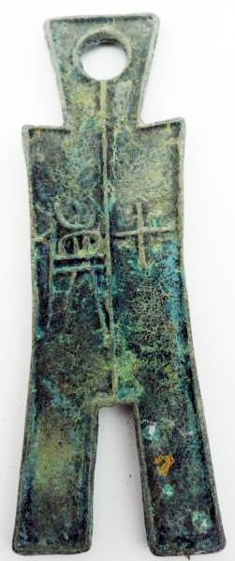 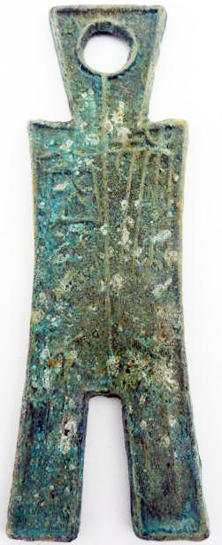

Square Foot Spade-Dang Jin Type (350-250 BCE)

Obv Pei Bi Dang Jin Rev Shi Huo. DCD 285, FD289. H 3.470 R 5